Lecture 5.3 - Link-State Routing Exercises

Link-State Routing

3
3
R7
A
2
R1
1
19
R2 8 R3
1
R6
R9
1
R8
R4 4 R5
2
B

3
1

1

For this problem, assume the network is running a link-state routing protocol, minimizing total route latency. The following questions indicate events that happen consecutively.
After convergence, what route does R7 think its packet will take to Host B?
1.1

EVENT: Ge R8-to-R9 link goes down.
R8 and R9 have recomputed their routes but have not yet sent updates to other routers. What route does
1.2
R7 think its packet will take to Host B?

What route does it actually take?
1.3

- Routing II

Assume all nodes are now aware of the new network state and have recomputed their routes. What route does a packet take from R3 to Host A?
1.4

EVENT: Ge cost of the R1-to-R2 link increases to 100.
R2 and R1 recompute their routes but have not yet sent updates to other routers. What route does R2
1.5
think its packet will take to Host A?

What route does it actually take?
1.6

Which additional routers must receive the routing updates and recompute their routes for all routers to be able to successfully send packets to Host A?
1.7

All routers except R3 have received the routing updates and recomputed their routes. Which routers can successfully send packets to Host A?
1.8

Routing II 3

2 More L3 Link State

1 1
A
R1 8 R2
2
3
4
4
R3 2 R4 3 R5
R6
2
3
4
4
B

8
R7
R8

After convergence, what is the path cost from A to B, and what are all the possible paths with this cost?
2.1

Suppose that a control message (a message used by the routing algorithm) takes 1 second to propagate along a link, regardless of link cost. What individual link failure inside the network would cause the longest delay to reconvergence, and what is that delay?
2.2

Suppose you have the ability to take down individual nodes. Which nodes would you take down in order to partition the network? If you can’t partition the network, which nodes would you take down to increase path costs from A to B maximally?
2.3
In each part, suppose you can take down:
- A single node (excluding R3 and R6).

- Two nodes (excluding R3 and R6).

Which single link’s cost (if any) should you double in order to increase the path cost from A to B?
2.4

Q4. Link-State
Consider the following network topology. All routers are running the link-state protocol. Each subpart is independent unless otherwise stated.
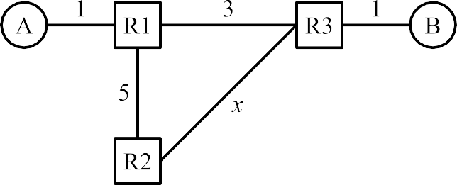

Q4.1 In total, how many “hello” advertisements get sent between the routers? Do not count periodically re-sent advertisements.
ANS:

Q4.2 Assume R1 doesn’t know about the R1-to-R3 link. All other routers know the full topology.
If , then a packet sent from A to B would get stuck in a routing loop. Fill in the blank with a strict inequality

Q4.3 What feature of the link-state protocol will help update the forwarding table to remove these routing loops?
- Routers send poison advertisements.
- Packets have a TTL field, and the packet is dropped when the TTL reaches 0.
- Advertisements are periodically re-sent.
- None of the above. The routing loops in the above scenarios will stay forever.
ANS:
Q4.4 What is a possible cause of the scenario where R1 doesn’t know about the R1-to-R3 link?
- Advertisement(s) get dropped.
- User packets get dropped.
- R1 is not running a correct shortest-path algorithm.
- The scenario where R1 doesn’t know about a link will never happen in the link-state protocol
ANS:
Q4.5 Suppose a routing loop has formed between R2 and R3. R2 forwards a user packet to R3, and then the same packet is sent back to R2. What will R2 do as a result of receiving this packet?
- Forward the packet to R3, and remove an entry from its forwarding table.
- Forward the packet to R3, and add an entry to its forwarding table.
- Forward the packet to a different router (not R3), and leave the forwarding table unchanged.
- Forward the packet to R3, and leave the forwarding table unchanged.
ANS:

